Behavior Tracker

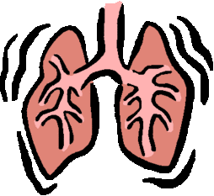

S

F

T

W

T

M

S



Progressive Muscle Relaxation

Breathing Retraining

Mindfulness